***Syed Muhammad Sarim***

***DLD Lab 1***

***24K-0718***

***Example: Z = AB+BC+AC’***

|  |  |  |  |
| --- | --- | --- | --- |
| ***A*** | ***B*** | ***C*** | ***Z*** |
| ***0*** | ***0*** | ***0*** | ***0*** |
| ***1*** | ***0*** | ***0*** | ***1*** |
| ***1*** | ***1*** | ***0*** | ***1*** |
| ***1*** | ***1*** | ***1*** | ***1*** |
| ***0*** | ***1*** | ***0*** | ***0*** |
| ***1*** | ***0*** | ***1*** | ***0*** |
| ***0*** | ***0*** | ***1*** | ***0*** |
| ***0*** | ***1*** | ***1*** | ***1*** |

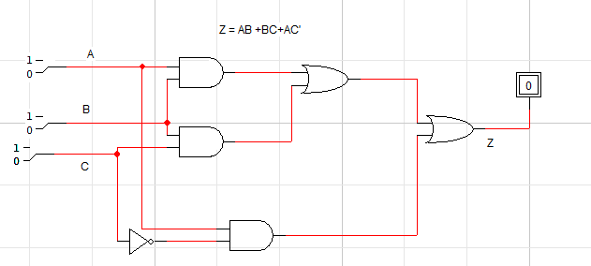

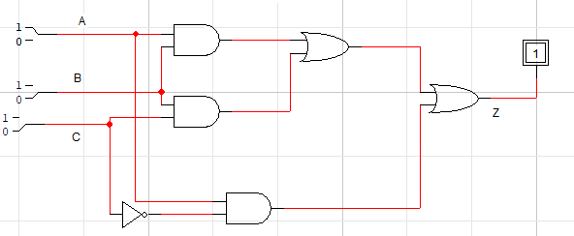

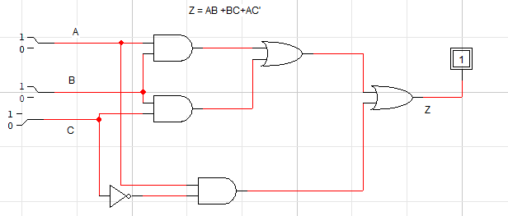

***Task 1:***

***Z = ((A’B)’+C) C’***

|  |  |  |  |
| --- | --- | --- | --- |
| ***A*** | ***B*** | ***C*** | ***Z*** |
| ***0*** | ***0*** | ***0*** | ***1*** |
| ***1*** | ***0*** | ***0*** | ***1*** |
| ***1*** | ***1*** | ***0*** | ***1*** |
| ***1*** | ***1*** | ***1*** | ***0*** |
| ***0*** | ***1*** | ***0*** | ***0*** |
| ***1*** | ***0*** | ***1*** | ***0*** |
| ***0*** | ***0*** | ***1*** | ***0*** |
| ***0*** | ***1*** | ***1*** | ***0*** |

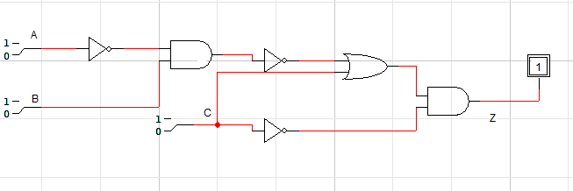

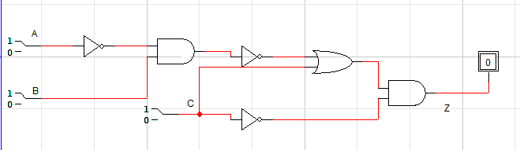

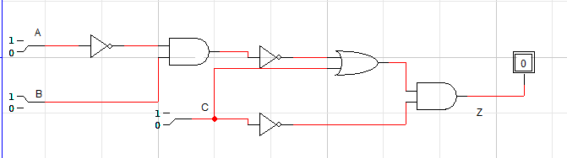

*Task 2:*

1. *Z = A+B+C+D*

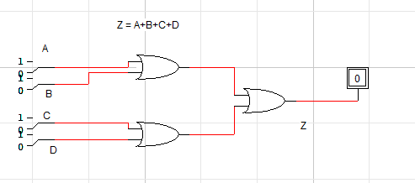

*B) Z = ABCD*

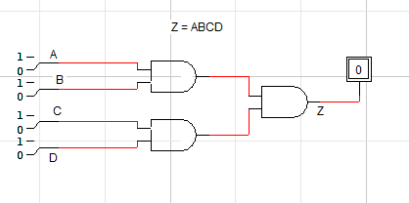

*C)Z = A+BC*

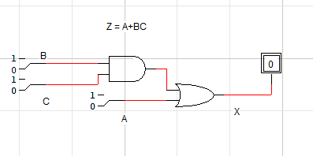

*D)Z = ABC+D*

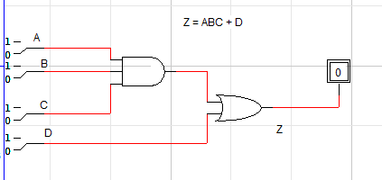

*Task 3:*

*Z = (AB+C) D’*

|  |  |  |  |  |
| --- | --- | --- | --- | --- |
| *A* | *B* | *C* | *D* | *Z* |
| *0* | *0* | *0* | *0* | *0* |
| *0* | *0* | *0* | *1* | *0* |
| *0* | *0* | *1* | *0* | *1* |
| *0* | *0* | *1* | *1* | *0* |
| *0* | *1* | *0* | *0* | *0* |
| *0* | *1* | *0* | *1* | *0* |
| *0* | *1* | *1* | *0* | *1* |
| *0* | *1* | *1* | *1* | *0* |
| *1* | *0* | *0* | *0* | *0* |
| *1* | *0* | *0* | *1* | *0* |
| *1* | *0* | *1* | *0* | *1* |
| *1* | *0* | *1* | *1* | *0* |
| *1* | *1* | *0* | *0* | *1* |
| *1* | *1* | *0* | *1* | *0* |
| *1* | *1* | *1* | *0* | *1* |
| *1* | *1* | *1* | *1* | *0* |

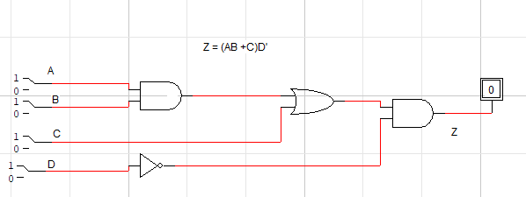

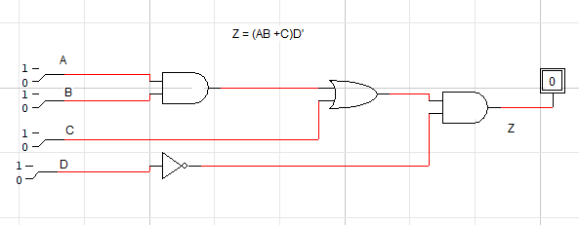

*Task 4:*

|  |  |  |  |
| --- | --- | --- | --- |
| *A* | *B* | *C* | *Z* |
| *0* | *0* | *0* | *0* |
| *0* | *0* | *1* | *0* |
| *0* | *1* | *0* | *0* |
| *0* | *1* | *1* | *1* |
| *1* | *0* | *0* | *0* |
| *1* | *0* | *1* | *0* |
| *1* | *1* | *0* | *1* |
| *1* | *1* | *1* | *1* |

